Department of
Artificial Intelligence and Machine Learning
B. Tech III Semester Academic Year 2026-2027
Data Analysis Essentials (2501AI06)
Capstone Stone Project Documentation

Surampalem, Kakinada District Andhra Pradesh-533437


School of Computing

Department of Artificial Intelligence and Machine Learning
DATA ANALYSIS ESSENTIALS

CERTIFICATE

This is to certify that the Cornerstone project work entitled “OTT STREAMING INSIGHTS AND CONTENT ANALYSIS” is submitted by

G SRITHAN GUPTA | (25B11AI372)
P SASANK | (25B11AI883)
B SRI RAM KISHAN | (25B11AI116)
CH VENKATA KOUSHIK | (25B11AI218)

in partial fulfilment of the requirements for the award of the B.Tech. degree in Artificial intelligence and machine learning the academic year 2026-2027.

Project Guide Head of the Department
S. Nagendra, Dr. K. Naga Bhargavi, Ph.D,
Assistant Professor, Associate Professor & HOD
Department of AIML Department of AIML

DECLARATION

We hereby declare that the project entitled “OTT STREAMING INSIGHTS AND CONTENT ANALYSIS” is our original work and is submitted to ADITYA UNIVERSITY, Surampalem, in partial fulfillment of the requirements for the award of the B.Tech. degree in Artificial Intelligence and Machine learning-
We further declare that this project work has not been submitted, either in full or in part, for the award of any degree or diploma in this or any other institution. We also confirm that this work has been carried out with academic honesty and complies with the Institutional Academic Integrity and AI Usage Policy.

Place:
Surampalem
Date:
By
G SRITHAN GUPTA | (25B11AI372)
P SASANK | (25B11AI883)
B SRI RAM KISHAN | (25B11AI116)
CH VENKATA KOUSHIK | (25B11AI218)

ACKNOWLEDGEMENT
It is with immense pleasure that we express our sincere gratitude to our Cornerstone Project Guide, Seelam Nagendra, Assistant Professor, who has guided us throughout the project. Her valuable support, encouragement, and guidance have greatly contributed to the successful completion of this work.
We would like to thank our Deputy Heads of the Department, Dr. Bollu Manikyala Rao, Associate Professor and Dr. Dasari Veeraswamy, Assistant Professor, Department of AIML, for their support and valuable suggestions.
Our deepest thanks to our Head of the Department, Dr. Kovvuri N Bhargavi, Associate Professor & HOD, for her inspiration and for providing all the necessary facilities and resources required for this project.
We also extend our sincere thanks to Dr. M.V. Rajesh, Associate Dean, School of Computing, for his encouragement and support during our project.
We would like to express our sincere gratitude to Dr. G. Suresh, Registrar; Dr. A. Ramesh, Pro Vice-Chancellor (Engineering & Sciences); Dr. S. Rama Sree, Pro Vice-Chancellor (Academics); Dr. M.B. Srinivas, Vice-Chancellor; and Dr. M. Sreenivasa Reddy, Deputy Pro Chancellor and Management, Aditya University, for providing excellent infrastructure and state-of-the-art laboratories.
Finally, we would like to thank the faculty members, lab technicians, non-teaching staff, and our friends who have directly or indirectly supported us in completing this Cornerstone project successfully.

— Project Team

ABSTRACT
The Over-The-Top (OTT) streaming industry has grown rapidly, with platforms such as Netflix, Amazon Prime Video, JioHotstar, and ZEE5 hosting vast and diverse content libraries. This Cornerstone project, titled “OTT Streaming Insights and Content Analysis,” applies the core techniques of Data Analysis Essentials to four independent OTT content datasets in order to uncover patterns in content type, genre, language, age rating, duration, and audience reception across these platforms.

The project workflow begins with loading the four raw datasets — Netflix, Amazon Prime Video, JioHotstar, and ZEE5 — each comprising several hundred titles described by sixteen attributes. Data quality issues, including missing values in fields such as Genre, Language, IMDb_Rating, and Age_Rating, along with duplicate records, were identified and resolved through mean/mode imputation and de-duplication. Numerical attributes were then transformed using Min-Max scaling and Z-score standardization, while categorical attributes such as Content_Type and Language were transformed using Label Encoding and One-Hot Encoding, respectively. Two project-specific derived features, Release_Decade and Duration_Category, were engineered to enable decade-wise and duration-wise analysis.

After preprocessing, the four cleaned datasets were combined into a single unified dataset of 2,015 records for comparative Exploratory Data Analysis (EDA). Eight distinct visualizations — bar graphs, a pie chart, a histogram, a box plot, a line chart, a scatter plot, and a project-specific grouped bar chart — were generated to examine content-type distribution, age-rating composition, genre popularity, language representation, duration segmentation, IMDb rating spread, release trends by decade, and the relationship between IMDb ratings and estimated viewership.

The analysis reveals that ZEE5 leans strongly toward Series content and Hindi-language titles, while Netflix, Amazon Prime Video, and JioHotstar are comparatively more Movie-heavy and English-dominant. Crime-Drama and Action-Thriller emerge as the most popular genres across platforms, and IMDb ratings cluster tightly between 7.5 and 8.5 across all four services, indicating broadly consistent content quality. This project demonstrates a complete, reproducible data-analysis pipeline — from raw data ingestion to actionable visual insight — and provides a foundation for further platform-level content strategy analysis.

TABLE OF CONTENTS
S.No. | Contents | Pages
1 | Title Page | i
2 | Certificate | ii
3 | Declaration | iii
4 | Acknowledgement | iv
5 | Abstract | v
6 | Table of Contents | vi
7 | List of Figures | viii
8 | List of Tables | ix

Chapter 1 | Introduction | 1
1.1 | Introduction to the Project | 1
1.2 | Problem Statement | 1
1.3 | Objectives of the Project | 1
1.4 | Scope of the Project | 1
Chapter 2 | Dataset Description and Understanding | 2
2.1 | Dataset Source | 2
2.2 | Dataset Description | 2
2.3 | Features / Attributes | 2
2.4 | Target Variable, if applicable | 3
2.5 | Dataset Statistics / Initial Exploration | 3
Chapter 3 | Data Preprocessing | 4
3.1 | Data Collection / Loading | 4
3.2 | Handling Missing Values | 4
3.3 | Handling Duplicate / Inconsistent Data | 5
3.4 | Feature Scaling | 5
3.5 | Standardization | 5
3.6 | Label Encoding | 6
3.7 | One-Hot Encoding | 6
3.8 | Other Project-Specific Preprocessing | 6
Chapter 4 | System Design and Methodology | 8
4.1 | Proposed Methodology | 8
4.2 | System Workflow / Architecture | 8
4.3 | Flowchart | 8
4.4 | Tools and Technologies Used | 9
4.5 | Algorithm / Model Used | 9
Chapter 5 | Implementation | 10
5.1 | Development Environment | 10
5.2 | Dataset Loading and Exploration | 10
5.3 | Preprocessing Implementation | 10
5.4 | Exploratory Data Analysis (EDA) | 11
5.5 | Model / Analysis Implementation | 11
5.6 | Important Code Explanation | 11
Chapter 6 | Data Visualization and Results | 12
6.1 | Bar Graph | 12
6.2 | Pie Chart | 13
6.3 | Histogram | 14
6.4 | Box Plot | 14
6.5 | Line Chart | 15
6.6 | Scatter Plot | 15
6.7 | Project-Specific Visualizations | 16
6.8 | Interpretation of Visualizations | 16
Chapter 7 | Model Evaluation / Analysis of Results | 17
7.1 | Evaluation Metrics | 17
7.2 | Experimental Results | 17
7.3 | Result Interpretation | 17
7.4 | Discussion | 17
Chapter 8 | Output Screenshots | 18
8.1 | Input / Dataset Screenshots | 18
8.2 | Preprocessing Outputs | 18
8.3 | Visualization Outputs | 18
8.4 | Prediction / Analysis Outputs | 18
Chapter 9 | Conclusion and Future Enhancements | 19
9.1 | Conclusion | 19
9.2 | Limitations | 19
9.3 | Future Enhancements | 19
10 | References | 20
11 | Appendix — Source Code | 21

LIST OF FIGURES
Fig. No. | Title | Page
1 | Movie and Series Distribution Across OTT Platforms (Bar Graph) | 12
2 | Genre Distribution Across OTT Platforms — Top 10 Genres (Bar Graph) | 13
3 | Age Rating Distribution Across OTT Platforms (Pie Charts) | 13
4 | OTT Content Duration Distribution (Histogram) | 14
5 | IMDb Rating Distribution Across OTT Platforms (Box Plot) | 14
6 | OTT Content Distribution by Release Decade (Line Chart) | 15
7 | IMDb Rating vs Estimated Views (Scatter Plot) | 16
8 | Language Distribution Across OTT Platforms — Top 10 Languages | 16

LIST OF TABLES
Tbl. No. | Title | Page
1 | Dataset Overview — Rows and Columns per Platform | 2
2 | Attribute / Feature Description | 2
3 | Missing Value Summary Before Cleaning | 4
4 | Duplicate Record Summary | 5
5 | Tools and Technologies Used | 9
6 | Movie vs Series Count by Platform | 17
7 | IMDb Rating Summary by Platform | 17

Chapter 1: Introduction

1.1 Introduction to the Project
The Over-The-Top (OTT) streaming industry has transformed the way audiences consume entertainment, with platforms such as Netflix, Amazon Prime Video, JioHotstar, and ZEE5 competing to deliver diverse content libraries across genres, languages, and formats. Each platform curates its catalogue differently — some emphasise international Movies, others focus on regional-language Series — and understanding these differences requires structured, data-driven analysis rather than casual observation.
This Cornerstone project, titled "OTT Streaming Insights and Content Analysis," applies the fundamental techniques taught in the Data Analysis Essentials course to four real-world-style OTT content datasets. The project covers the complete data analysis lifecycle: loading raw data, understanding its structure, cleaning and preprocessing it, engineering new features, performing exploratory data analysis (EDA), and finally visualizing and interpreting the results to derive meaningful, platform-level insights.

1.2 Problem Statement
OTT platforms independently publish large volumes of content metadata, but this data is rarely clean, standardized, or directly comparable across platforms. Each dataset used in this project contains missing values, duplicate records, and inconsistent formatting. Without proper preprocessing and a unified analytical approach, it is difficult to answer basic but important business questions such as: Which platform favours Movies over Series? Which age ratings and genres dominate each platform? How does content duration vary? and How do IMDb ratings relate to estimated viewership? This project addresses the problem of transforming four disparate, imperfect OTT datasets into a single, clean, analysis-ready dataset capable of answering these questions with statistical and visual evidence.

1.3 Objectives of the Project
- To load and understand the structure of four independent OTT platform datasets (Netflix, Amazon Prime Video, JioHotstar, and ZEE5).
- To identify and handle missing values and duplicate records in each dataset.
- To apply feature scaling (Min-Max Scaling) and standardization (Z-score) to numerical attributes.
- To apply Label Encoding and One-Hot Encoding to categorical attributes such as Content_Type and Language.
- To engineer project-specific derived features — Release_Decade and Duration_Category.
- To combine the four cleaned datasets into a single unified dataset for comparative analysis.
- To perform Exploratory Data Analysis (EDA) and generate meaningful visualizations (bar graphs, pie chart, histogram, box plot, line chart, and scatter plot).
- To interpret the visual and statistical results and derive actionable content insights across the four OTT platforms.

1.4 Scope of the Project
The scope of this project is limited to descriptive and exploratory data analysis of the four supplied OTT datasets; it does not involve building a predictive machine-learning model, nor does it involve live/streaming data collection from the actual OTT platforms. The analysis is restricted to the attributes present in the datasets — Content_ID, Content_Name, Content_Type, Release_Year, Genre, Language, Country, Duration_Minutes, IMDb_Rating, Age_Rating, Director, Lead_Actor, Platform, Estimated_Views_Millions, User_Rating, and Estimated_Watch_Hours. The project is implemented in Python using Pandas, Scikit-learn, and Matplotlib within the Google Colab environment.

Chapter 2: Dataset Description and Understanding

2.1 Dataset Source
Four independent OTT content datasets were used in this project, supplied as Microsoft Excel (.xlsx) files and loaded using the Pandas read_excel() function within a Google Colab notebook connected to Google Drive:
- Netflix_OTT_DAE_620.xlsx
- Amazon_Prime_OTT_DAE_650.xlsx
- JioHotstar_OTT_DAE_610.xlsx
- ZEE5_OTT_DAE_630.xlsx
Each file represents the content catalogue metadata of a single OTT platform, curated specifically for practicing data-analysis and preprocessing techniques.

2.2 Dataset Description
Each of the four datasets shares an identical schema of 16 columns, differing only in the number of rows (titles) and in the amount and type of missing data deliberately introduced for preprocessing practice. The initial shape of each raw dataset, before any cleaning, was as follows:
Table 1: Dataset Overview — Rows and Columns per Platform
Platform | Rows (Titles) | Columns
Netflix | 620 | 16
Amazon Prime Video | 650 | 16
JioHotstar | 610 | 16
ZEE5 | 630 | 16

2.3 Features / Attributes
Every dataset contains the following sixteen attributes describing each content title:
Table 2: Attribute / Feature Description
S.no | Attribute | Description
1 | Content_ID | Unique identifier for the title
2 | Content_Name | Name of the Movie or Series
3 | Content_Type | Categorical — Movie or Series
4 | Release_Year | Year the content was released
5 | Genre | One or more genres (e.g., Crime, Drama)
6 | Language | Primary audio language(s)
7 | Country | Country of production
8 | Duration_Minutes | Runtime / episode length in minutes
9 | IMDb_Rating | IMDb rating out of 10
10 | Age_Rating | Content maturity rating (U, U/A, A, TV-14, TV-MA, TV-PG)
11 | Director | Name of the director
12 | Lead_Actor | Name of the lead actor
S.no | Attribute | Description
13 | Platform | OTT platform name
14 | Estimated_Views_Millions | Estimated viewership in millions
15 | User_Rating | Platform user rating
16 | Estimated_Watch_Hours | Estimated cumulative watch hours

2.4 Target Variable, if applicable
This project is analytical/descriptive in nature rather than predictive, so there is no single formal target variable used for supervised modelling. However, Content_Type (Movie / Series) is treated as the primary categorical variable of interest for classification-style comparison across platforms, and it is Label-Encoded in Section 3.6 for this purpose. IMDb_Rating and Estimated_Views_Millions serve as the key continuous variables examined for relationships and trends.

2.5 Dataset Statistics / Initial Exploration
The Netflix dataset's column list, data types, and a preview of the first five records are representative of the structure shared across all four platforms:
print("Number of columns in each dataset:")
print("Netflix:", len(netflix_df.columns))
...
for i, column in enumerate(netflix_df.columns, start=1):
print(f"{i}. {column}")

Output:
Number of columns in each dataset:
Netflix: 16 Amazon Prime: 16 JioHotstar: 16 ZEE5: 16

Column Names:
1. Content_ID 6. Language 11. Director
2. Content_Name 7. Country 12. Lead_Actor
3. Content_Type 8. Duration_Minutes 13. Platform
4. Release_Year 9. IMDb_Rating 14. Estimated_Views_Millions
5. Genre 10. Age_Rating 15. User_Rating
16. Estimated_Watch_Hours

A preview of the first record of the Netflix dataset (netflix_df.head()) confirms the data types and content:
Output:
Content_ID: NF1001 Content_Name: Stranger Things Content_Type: Series
Release_Year: 2016 Genre: Sci-Fi, Drama Language: English
Country: USA Duration_Minutes: 55 IMDb_Rating: 8.6
Age_Rating: TV-14 Director: The Duffer Brothers
Lead_Actor: Millie Bobby Brown Platform: Netflix
Estimated_Views_Millions: 4.44 User_Rating: 4.3
Estimated_Watch_Hours: 1953292

The data types (netflix_df.dtypes) confirm four numeric columns (Release_Year, Duration_Minutes, IMDb_Rating as float, Estimated_Views_Millions, Estimated_Watch_Hours) and the remaining columns as categorical/text (object) columns, which directly informs the preprocessing strategy adopted in Chapter 3.

Chapter 3: Data Preprocessing
Data preprocessing is performed to improve the quality, consistency, and analytical readiness of the four OTT datasets. This chapter documents every preprocessing step applied — missing value treatment, duplicate removal, feature scaling, standardization, label encoding, one-hot encoding, and project-specific feature engineering.

3.1 Data Collection / Loading
The four datasets were loaded directly from Google Drive into Pandas DataFrames using read_excel(), one DataFrame per OTT platform (netflix_df, prime_df, jio_df, zee5_df). This platform-wise separation was intentionally preserved through the entire cleaning and preprocessing stage so that each platform's data quality issues could be diagnosed and treated independently before the datasets were finally combined for comparative analysis in Chapter 5.
netflix_df = pd.read_excel(".../Netflix_OTT_DAE_Preprocessing_Practice_620.xlsx")
prime_df = pd.read_excel(".../Amazon_Prime_OTT_DAE_Preprocessing_Practice_650.xlsx")
jio_df = pd.read_excel(".../JioHotstar_OTT_DAE_Preprocessing_Practice_610.xlsx")
zee5_df = pd.read_excel(".../ZEE5_OTT_DAE_Preprocessing_Practice_630_42Missing.xlsx")

3.2 Handling Missing Values
Before cleaning, each raw dataset was checked for missing values using isnull().sum(). The results, summarized below, show that JioHotstar was supplied fully clean, while Netflix, Amazon Prime Video, and ZEE5 (deliberately, as indicated by its filename) contained missing entries across several columns.
Table 3: Missing Value Summary Before Cleaning (non-zero columns only)
Platform | Genre | Language | Country | Duration_Min. | IMDb_Rating | Age_Rating | Director | Lead_Actor | Views | User_Rating
Netflix | 5 | 5 | 0 | 0 | 5 | 5 | 0 | 0 | 0 | 0
Amazon Prime | 5 | 5 | 5 | 5 | 5 | 7 | 7 | 4 | 5 | 4
JioHotstar | 0 | 0 | 0 | 0 | 0 | 0 | 0 | 0 | 0 | 0
ZEE5 | 11 | 11 | 0 | 0 | 11 | 9 | 0 | 0 | 0 | 0
Missing values were handled column-wise, using an approach suited to each attribute's data type: categorical columns (Genre, Language, Age_Rating, Country, Director, Lead_Actor) were filled with the placeholder "Unknown", while numerical columns (IMDb_Rating, Duration_Minutes, Estimated_Views_Millions, User_Rating) were filled with the column mean.
# Netflix
netflix_df["Genre"] = netflix_df["Genre"].fillna("Unknown")
netflix_df["Language"] = netflix_df["Language"].fillna("Unknown")
netflix_df["IMDb_Rating"] = netflix_df["IMDb_Rating"].fillna(netflix_df["IMDb_Rating"].mean())
netflix_df["Age_Rating"] = netflix_df["Age_Rating"].fillna("Unknown")

# Amazon Prime (additional columns with missing data)
prime_df["Country"] = prime_df["Country"].fillna("Unknown")
prime_df["Duration_Minutes"] = prime_df["Duration_Minutes"].fillna(prime_df["Duration_Minutes"].mean())
prime_df["Director"] = prime_df["Director"].fillna("Unknown")
prime_df["Lead_Actor"] = prime_df["Lead_Actor"].fillna("Unknown")
prime_df["Estimated_Views_Millions"] = prime_df["Estimated_Views_Millions"].fillna(prime_df["Estimated_Views_Millions"].mean())
prime_df["User_Rating"] = prime_df["User_Rating"].fillna(prime_df["User_Rating"].mean())

# ZEE5
zee5_df["Genre"] = zee5_df["Genre"].fillna("Unknown")
zee5_df["Language"] = zee5_df["Language"].fillna("Unknown")
zee5_df["IMDb_Rating"] = zee5_df["IMDb_Rating"].fillna(zee5_df["IMDb_Rating"].mean())
zee5_df["Age_Rating"] = zee5_df["Age_Rating"].fillna("Unknown")
Output:
Verification — total remaining missing values after cleaning:
Netflix: 0 Amazon Prime: 0 JioHotstar: 0 ZEE5: 0

3.3 Handling Duplicate / Inconsistent Data
Each dataset was also checked for fully duplicated rows using duplicated().sum(). A significant number of duplicate records were found in every platform's dataset, which were then removed using drop_duplicates() to ensure that repeated rows did not artificially inflate any counts during analysis.
Table 4: Duplicate Record Summary — Before and After Removal
Platform | Duplicates Found | Duplicates After drop_duplicates()
Netflix | 116 | 0
Amazon Prime Video | 150 | 0
JioHotstar | 110 | 0
ZEE5 | 119 | 0
netflix_df = netflix_df.drop_duplicates()
prime_df = prime_df.drop_duplicates()
jio_df = jio_df.drop_duplicates()
zee5_df = zee5_df.drop_duplicates()

3.4 Feature Scaling
Feature scaling brings numerical features onto a common scale, which is important when features have very different ranges (e.g., Duration_Minutes in tens/hundreds vs. Estimated_Watch_Hours in millions). Min-Max Scaling (scikit-learn's MinMaxScaler) was applied to four numerical attributes — Duration_Minutes, IMDb_Rating, Estimated_Views_Millions, and Estimated_Watch_Hours — rescaling every value into the range [0, 1] independently for each platform.
from sklearn.preprocessing import MinMaxScaler
scaler = MinMaxScaler()

netflix_scaled = scaler.fit_transform(
netflix_df[["Duration_Minutes", "IMDb_Rating",
"Estimated_Views_Millions", "Estimated_Watch_Hours"]]
)
Output:
Netflix Scaled Data (first row):
[0.1149 0.7667 0.1734 0.0309]
Amazon Prime Scaled Data (first row):
[0.2160 0.8627 0.0456 0.0139]

3.5 Standardization
Standardization (Z-score, via scikit-learn's StandardScaler) transforms numerical features to have a mean of 0 and a standard deviation of 1. This was applied to the same four numerical attributes and is particularly useful for statistical comparison of ratings and durations independent of their original units.
from sklearn.preprocessing import StandardScaler
scaler = StandardScaler()

netflix_standardized = scaler.fit_transform(
netflix_df[["Duration_Minutes", "IMDb_Rating",
"Estimated_Views_Millions", "Estimated_Watch_Hours"]]
)
Output:
Netflix Standardized Data (first row):
[-1.0982 0.7162 -0.8357 -0.9935]
JioHotstar Standardized Data (first row):
[ 0.8564 0.0022 -0.5165 0.2130]

3.6 Label Encoding
Label Encoding converts categorical values into numeric labels. It was applied to the Content_Type attribute (values: Movie, Series) using scikit-learn's LabelEncoder, producing a new Content_Type_Encoded column where Movie = 0 and Series = 1 — a mapping used extensively for content-type comparison in Chapters 5–6.
from sklearn.preprocessing import LabelEncoder
label_encoder = LabelEncoder()

netflix_encoded = netflix_df.copy()
netflix_encoded["Content_Type_Encoded"] = label_encoder.fit_transform(
netflix_encoded["Content_Type"]
)
Output:
Content_Type Content_Type_Encoded
Series 1
Series 1
Movie 0 (JioHotstar row 0)

3.7 One-Hot Encoding
One-Hot Encoding converts a categorical attribute into multiple binary columns — one per category. It was applied to the Language attribute using scikit-learn's OneHotEncoder, producing, for example, 14 binary columns for Netflix (English, English/Spanish, French, German, Hindi, Japanese, Kannada, Korean, Malayalam, Spanish, Tamil, Telugu, Telugu/Hindi, Unknown), 10 for Amazon Prime Video, 7 for JioHotstar, and 8 for ZEE5, reflecting each platform's linguistic diversity.
from sklearn.preprocessing import OneHotEncoder
encoder = OneHotEncoder(sparse_output=False)

netflix_onehot = encoder.fit_transform(netflix_df[["Language"]])
print(encoder.fit(netflix_df[["Language"]]).categories_[0])
Output:
Netflix Languages (14): ['English' 'English, Spanish' 'French' 'German' 'Hindi'
'Japanese' 'Kannada' 'Korean' 'Malayalam' 'Spanish' 'Tamil' 'Telugu'
'Telugu, Hindi' 'Unknown']
ZEE5 Languages (8): ['Hindi' 'Kannada' 'Malayalam' 'Tamil' 'Telugu'
'Telugu, Hindi' 'Unknown' 'Urdu']

3.8 Other Project-Specific Preprocessing
Two additional attributes were engineered specifically for this project to support deeper, business-relevant analysis:
- Release_Decade — derived from Release_Year using integer division ((Release_Year // 10) * 10), enabling decade-wise trend analysis (Section 5.7).
- Duration_Category — derived from Duration_Minutes and bucketed into Short (< 60 min), Medium (60–120 min), and Long (> 120 min), enabling duration-based content segmentation (Section 5.5, Chapter 6.3).
netflix_df["Release_Decade"] = (netflix_df["Release_Year"] // 10) * 10

def duration_category(minutes):
if minutes < 60: return "Short"
elif minutes <= 120: return "Medium"
else: return "Long"

netflix_df["Duration_Category"] = netflix_df["Duration_Minutes"].apply(duration_category)
Output:
Netflix -> Release_Year 2016 => Release_Decade 2010 | Duration 55 => Short
JioHotstar-> Release_Year 2015 => Release_Decade 2010 | Duration 159 => Long
ZEE5 -> Release_Year 2018 => Release_Decade 2010 | Duration 110 => Medium

Chapter 4: System Design and Methodology

4.1 Proposed Methodology
The project follows the standard applied data-analysis methodology: data acquisition, data understanding, data cleaning, feature engineering/transformation, data integration, exploratory data analysis, visualization, and interpretation. Each of the four OTT datasets is first processed independently so that platform-specific data-quality issues can be resolved without cross-contamination, after which the cleaned datasets are combined into one unified DataFrame for comparative, platform-level analysis.

4.2 System Workflow / Architecture
The end-to-end workflow implemented in the Google Colab notebook proceeds through the following stages:
- Stage 1 — Data Ingestion: Load four .xlsx files (Netflix, Amazon Prime Video, JioHotstar, ZEE5) into separate Pandas DataFrames.
- Stage 2 — Data Understanding: Inspect shape, column names, data types, and preview records for each platform.
- Stage 3 — Data Cleaning: Detect and treat missing values (mean / "Unknown" imputation) and remove duplicate rows.
- Stage 4 — Feature Transformation: Apply Min-Max scaling, Z-score standardization, Label Encoding, and One-Hot Encoding.
- Stage 5 — Feature Engineering: Derive Release_Decade and Duration_Category.
- Stage 6 — Data Integration: Concatenate the four cleaned DataFrames into a single combined_df (2,015 records) with the Platform column retained as the group key.
- Stage 7 — Exploratory Data Analysis: Compute platform-wise statistics for content type, age rating, genre, language, duration, IMDb rating, and release decade.
- Stage 8 — Visualization & Interpretation: Generate eight charts (bar, pie, histogram, box plot, line, scatter, and grouped bar charts) and interpret the resulting patterns.

4.3 Flowchart
The following flow represents the sequential pipeline implemented in this project:
[Load 4 OTT Excel Datasets]
|
v
[Inspect Shape / Columns / Dtypes]
|
v
[Handle Missing Values] ---> [Remove Duplicate Rows]
|
v
[Scaling] [Standardization] [Label Encoding] [One-Hot Encoding]
|
v
[Feature Engineering: Release_Decade, Duration_Category]
|
v
[Combine 4 Cleaned Datasets -> combined_df (2015 rows)]
|
v
[Exploratory Data Analysis: Content Type / Age / Genre / Language /
Duration / IMDb Rating / Release Decade / Views]
|
v
[Visualization: Bar, Pie, Histogram, Box Plot, Line, Scatter]
|
v
[Interpretation & Insights]

4.4 Tools and Technologies Used
Table 5: Tools and Technologies Used
Category | Tool / Library
Programming Language | Python 3
Development Environment | Google Colab (Jupyter Notebook)
Data Handling | Pandas
Preprocessing / Encoding | Scikit-learn (MinMaxScaler, StandardScaler, LabelEncoder, OneHotEncoder)
Visualization | Matplotlib
Data Storage / Source | Google Drive (.xlsx files)
Documentation | Microsoft Word (.docx)

4.5 Algorithm / Model Used
As this project is descriptive and exploratory rather than predictive, no supervised machine-learning model (e.g., classifier or regressor) was trained. Instead, the "algorithmic" core of the project consists of the preprocessing algorithms — Min-Max normalization, Z-score standardization, Label Encoding, and One-Hot Encoding — together with group-wise statistical aggregation (value_counts(), mean(), max(), min(), idxmax()) applied per platform via the Pandas groupby-style filtering pattern (platform_data = combined_df[combined_df["Platform"] == platform]). This approach is appropriate for the project's objective of comparative content analysis rather than prediction.

Chapter 5: Implementation

5.1 Development Environment
The project was implemented and executed entirely in Google Colab, a cloud-based Jupyter notebook environment, using the Google Drive integration to store and access the four source Excel datasets. The notebook (PROJECT_2.ipynb) contains 79 cells organized into markdown section headers and executable Python code cells, structured to mirror the standard data-analysis pipeline: library imports, dataset loading, dataset understanding, preprocessing, EDA, and visualization.

5.2 Dataset Loading and Exploration
The required libraries — Pandas for data handling, Scikit-learn's preprocessing module, and Matplotlib for visualization — were imported first, followed by loading the four datasets and exploring their shape, columns, and data types (see Section 2.5 for full output).
import pandas as pd
from sklearn.preprocessing import StandardScaler
import matplotlib.pyplot as plt
from google.colab import files

netflix_df = pd.read_excel("/content/drive/MyDrive/Netflix_OTT_DAE_Preprocessing_Practice_620.xlsx")
prime_df = pd.read_excel("/content/drive/MyDrive/Amazon_Prime_OTT_DAE_Preprocessing_Practice_650.xlsx")
jio_df = pd.read_excel("/content/drive/MyDrive/JioHotstar_OTT_DAE_Preprocessing_Practice_610.xlsx")
zee5_df = pd.read_excel("/content/drive/MyDrive/ZEE5_OTT_DAE_Preprocessing_Practice_630_42Missing.xlsx")

print("Netflix:", netflix_df.shape)
print("Amazon Prime:", prime_df.shape)
print("JioHotstar:", jio_df.shape)
print("ZEE5:", zee5_df.shape)
Output:
Netflix: (620, 16) Amazon Prime: (650, 16) JioHotstar: (610, 16) ZEE5: (630, 16)

5.3 Preprocessing Implementation
The full preprocessing implementation — missing value handling, duplicate removal, scaling, standardization, label encoding, one-hot encoding, and feature engineering — is documented in complete detail with code and output in Chapter 3 (Sections 3.2–3.8) and is not repeated here. The key implementation pattern used throughout is per-platform transformation followed by final concatenation:
combined_df = pd.concat(
[netflix_df, prime_df, jio_df, zee5_df],
ignore_index=True
)
print("Combined Dataset Shape:", combined_df.shape)
print(combined_df["Platform"].value_counts())
Output:
Combined Dataset Shape: (2015, 18)

Platform-wise Record Count:
ZEE5 511
Netflix 504
Amazon Prime Video 500
JioHotstar 500

5.4 Exploratory Data Analysis (EDA)
EDA was performed on the combined dataset by filtering platform-wise subsets and computing descriptive statistics for each attribute of interest. The general implementation pattern used across all EDA sections is:
platforms = combined_df["Platform"].unique()

for platform in platforms:
platform_data = combined_df[combined_df["Platform"] == platform]
# compute value_counts(), mean(), max(), min(), idxmax() as required
...
This pattern was applied to compute: Movie vs Series counts (Section 6.8 / Chapter 7), Age Rating distribution, highest Genre per platform, highest Language per platform, Duration_Category distribution, IMDb rating statistics (mean/max/min), release-decade-wise title counts, and the relationship between Estimated_Views_Millions and IMDb_Rating. Full numeric results of each of these analyses are presented in Chapter 7 (Experimental Results).

5.5 Model / Analysis Implementation
Since the project is analytical rather than predictive, the "model" implemented is a rule-based feature-engineering and aggregation pipeline rather than a trained statistical/ML model. The Duration_Category classifier function is representative of this rule-based approach:
def duration_category(minutes):
if minutes < 60:
return "Short"
elif minutes <= 120:
return "Medium"
else:
return "Long"

combined_df["Duration_Category"] = combined_df["Duration_Minutes"].apply(duration_category)

5.6 Important Code Explanation
- fillna(mean()) — imputes missing numeric values with the column average, preserving the overall distribution shape better than dropping rows.
- drop_duplicates() — removes exact duplicate rows, applied after loading to prevent double-counting in later aggregations.
- MinMaxScaler().fit_transform() — rescales each numeric column independently into [0, 1] using (x − min) / (max − min).
- StandardScaler().fit_transform() — rescales each numeric column to zero mean and unit variance using (x − μ) / σ.
- LabelEncoder().fit_transform() — assigns an integer label (0, 1, 2, …) to each unique category, sorted alphabetically by default (Movie=0, Series=1).
- OneHotEncoder(sparse_output=False).fit_transform() — converts a single categorical column into N binary columns, one per unique category.
- pd.concat([...], ignore_index=True) — vertically stacks the four cleaned, per-platform DataFrames into one combined_df with a fresh continuous index.
- value_counts() / idxmax() / mean() — core Pandas aggregation functions used throughout the EDA to summarize categorical distributions and numeric statistics per platform.

Chapter 6: Data Visualization and Results
This chapter presents the eight core visualizations generated from the combined OTT dataset (2,015 records) using Matplotlib. Each visualization directly answers one of the analysis questions defined for this project, and is accompanied by a short interpretation of the observed pattern.

6.1 Bar Graph

Movie and Series Distribution Across OTT Platforms
This grouped bar graph compares the number of Movies and Series available on each of the four OTT platforms, using the Content_Type_Encoded values computed in Section 3.6.
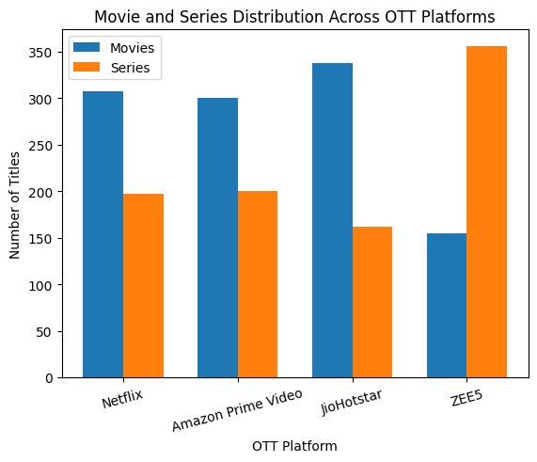
Figure 1: Movie and Series Distribution Across OTT Platforms
ZEE5 stands out with a clear Series-dominant catalogue (356 Series vs. 155 Movies), while Netflix, Amazon Prime Video, and JioHotstar are comparatively Movie-heavy — JioHotstar most strongly so, with 338 Movies against only 162 Series.

6.1.1 Most Common Genre Across OTT Platforms
This grouped bar graph compares the top 10 most common genres across all four platforms.
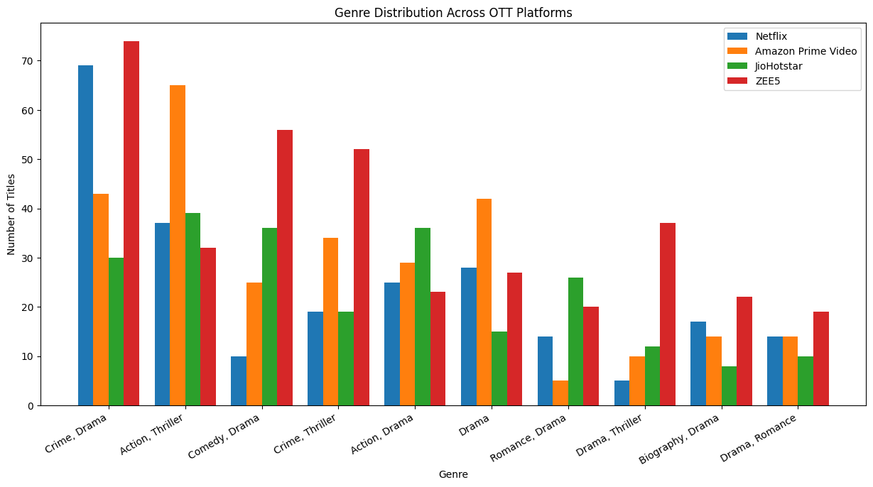
Figure 2: Genre Distribution Across OTT Platforms (Top 10 Genres)
Crime-Drama is the leading genre on both Netflix (69 titles) and ZEE5 (74 titles), while Action-Thriller leads on Amazon Prime Video (65) and JioHotstar (39). Comedy-Drama and Crime-Thriller are also strongly represented on ZEE5, indicating a heavier regional drama focus compared with the other platforms.

6.2 Pie Chart

Age Rating Distribution Across OTT Platforms
Four pie charts (one per platform) show the proportional breakdown of Age_Rating categories.
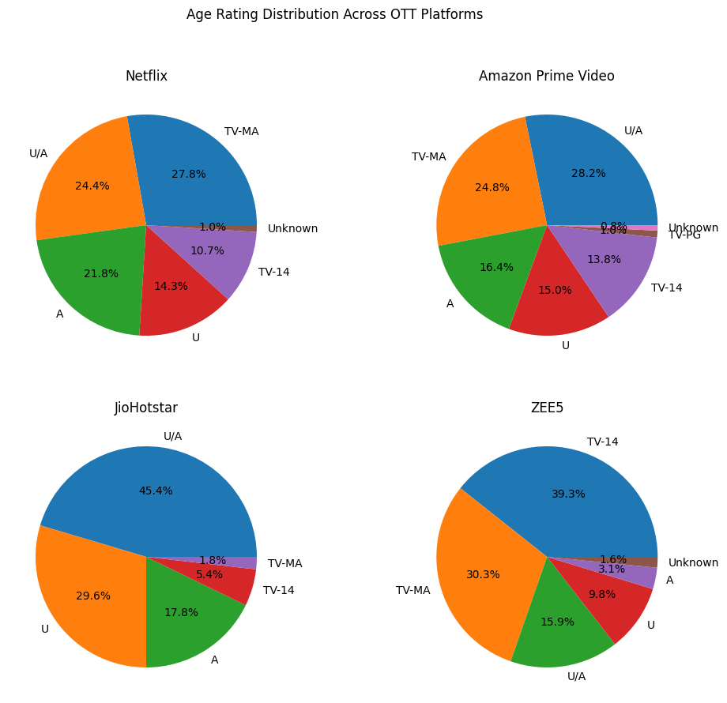
Figure 3: Age Rating Distribution Across OTT Platforms
Netflix and Amazon Prime Video show a relatively balanced spread across TV-MA, U/A, and A ratings. JioHotstar skews toward family-friendly content, with U/A (227) and U (148) dominating. ZEE5 leans toward TV-14 (201) and TV-MA (155), reflecting a more mature-audience regional catalogue.

6.3 Histogram

Content Duration Distribution
This histogram shows the distribution of Duration_Minutes across the entire combined dataset, in 10 bins.
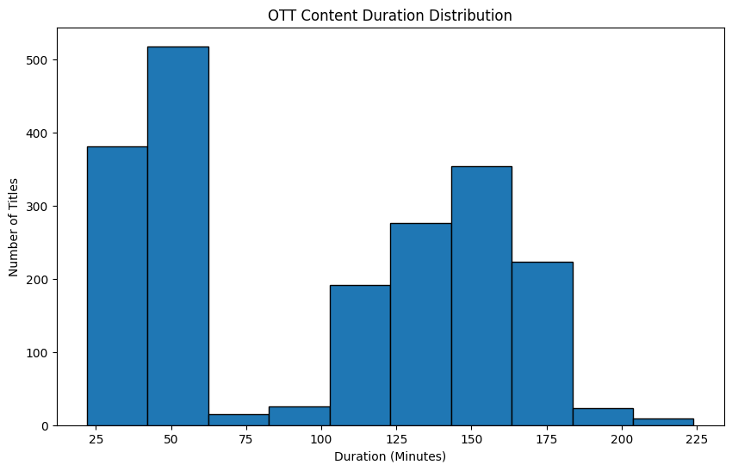
Figure 4: OTT Content Duration Distribution
The distribution is bimodal: a large cluster of short-duration titles (Series episodes, typically under 60 minutes) and a second cluster of longer feature-length Movies (100–180 minutes), with comparatively fewer titles in the 60–90-minute middle range.

6.4 Box Plot

IMDb Rating Distribution Across OTT Platforms
This box plot compares the spread, median, and outliers of IMDb_Rating across the four platforms.
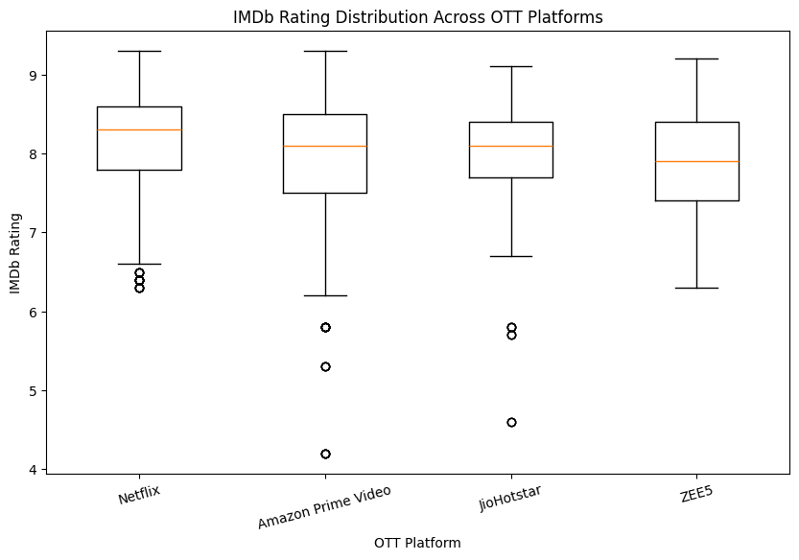
Figure 5: IMDb Rating Distribution Across OTT Platforms
All four platforms show a tightly clustered median IMDb rating between roughly 7.8 and 8.1, with Netflix showing a slightly higher central tendency (mean 8.14) and Amazon Prime Video the widest spread (ratings ranging from 4.2 to 9.3), indicating greater variability in content quality on that platform.

6.5 Line Chart

OTT Content Distribution by Release Decade
This line chart tracks the number of titles released in each decade, plotted separately for each platform.
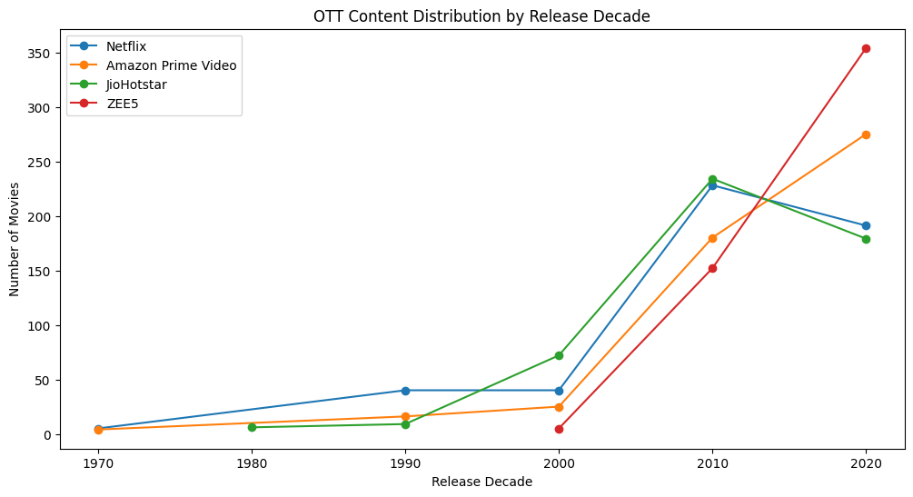
Figure 6: OTT Content Distribution by Release Decade
All four platforms show a sharp upward trend from the 2000s into the 2010s and 2020s, consistent with the real-world growth of OTT-original and digitally distributed content. ZEE5's catalogue is the most concentrated in the most recent decade (354 titles from the 2020s alone), while Netflix and JioHotstar retain a more substantial share of 2010s-era titles.

6.6 Scatter Plot

IMDb Rating and Estimated Views Analysis
This scatter plot examines the relationship between Estimated_Views_Millions and IMDb_Rating, coloured by platform.
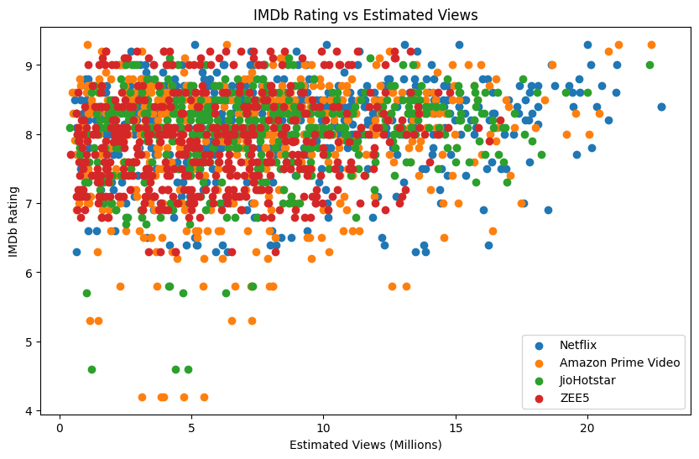
Figure 7: IMDb Rating vs Estimated Views
No strong linear correlation is visible between viewership and IMDb rating — highly viewed titles exist at both high and moderate rating levels, suggesting that estimated viewership on these platforms is driven more by promotion, genre popularity, and content type than by critical/audience rating alone.

6.7 Project-Specific Visualizations

Language Distribution Across OTT Platforms
This grouped bar chart compares the number of titles in the top 10 most common languages across all four platforms — a project-specific visualization chosen because language representation is a key differentiator for regional OTT platforms in the Indian market.
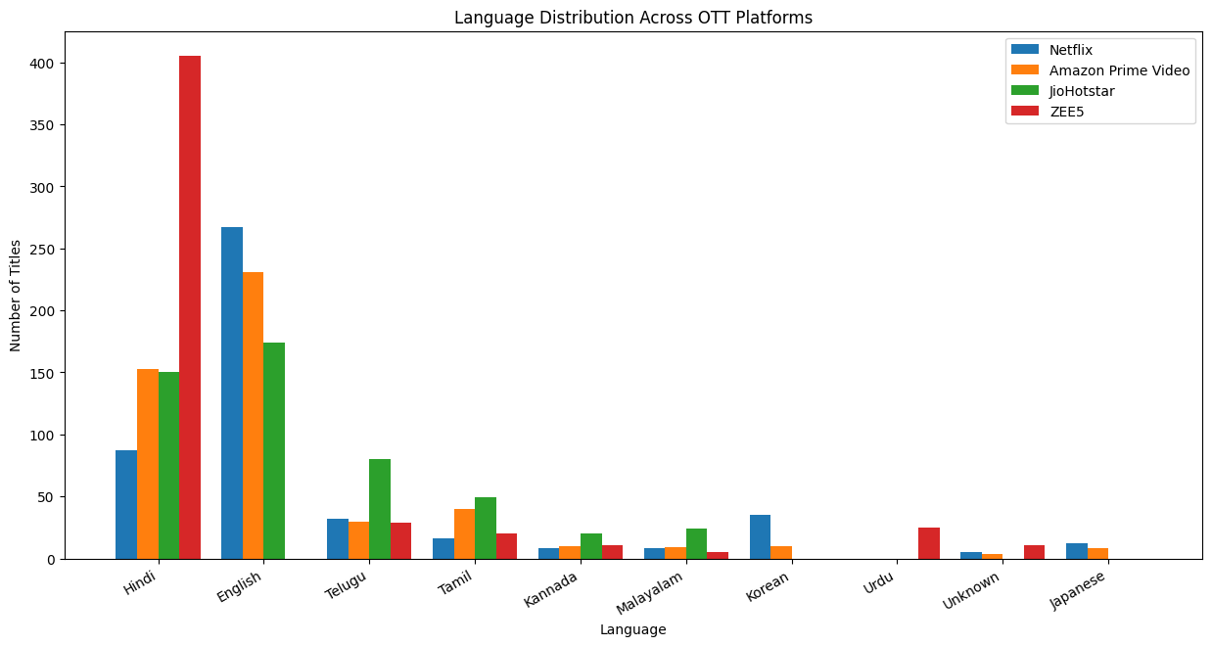
Figure 8: Language Distribution Across OTT Platforms (Top 10 Languages)
English dominates on Netflix (267), Amazon Prime Video (231), and JioHotstar (174), reflecting their international content libraries, while ZEE5 is overwhelmingly Hindi-first (405 titles), confirming its positioning as a regional/Hindi-language-focused platform.

6.8 Interpretation of Visualizations
- Content-type strategy differs sharply by platform: ZEE5 is Series/regional-drama-led, while JioHotstar, Netflix, and Amazon Prime Video are relatively more Movie-led.
- Crime-Drama and Action-Thriller are the two dominant genres across the industry, appearing as the top genre on at least one platform each.
- Content duration follows the expected bimodal Movie/Series pattern, validating the Short/Medium/Long categorization introduced in Section 3.8.
- IMDb ratings are remarkably consistent across platforms (means between 7.88 and 8.14), suggesting no single platform has a systematically higher- or lower-quality catalogue by this metric.
- Release-decade trends confirm the industry-wide shift toward recent-decade content, most pronounced on ZEE5.
- Viewership (Estimated_Views_Millions) shows no strong dependence on IMDb rating, implying other factors (marketing, genre, star power) drive OTT viewership more than critical reception.
- Language distribution clearly separates the platforms into an English-first group (Netflix, Amazon Prime Video, JioHotstar) and a Hindi-first group (ZEE5).

Chapter 7: Model Evaluation / Analysis of Results

7.1 Evaluation Metrics
As this project performs exploratory and comparative data analysis rather than supervised prediction, no classification/regression evaluation metrics (accuracy, precision, RMSE, etc.) apply. Instead, the project is "evaluated" through descriptive statistical metrics computed per platform: count and proportion (value_counts()), central tendency and spread (mean, max, min of IMDb_Rating), and categorical dominance (idxmax() for the leading Genre / Language / Age_Rating per platform).

7.2 Experimental Results
Table 6: Movie vs Series Count by Platform
Platform | Movies | Series | Total
Netflix | 307 | 197 | 504
Amazon Prime Video | 300 | 200 | 500
JioHotstar | 338 | 162 | 500
ZEE5 | 155 | 356 | 511
Table 7: IMDb Rating Summary by Platform
Platform | Average | Highest | Lowest
Netflix | 8.14 | 9.3 | 6.3
Amazon Prime Video | 7.90 | 9.3 | 4.2
JioHotstar | 8.00 | 9.1 | 4.6
ZEE5 | 7.88 | 9.2 | 6.3
Highest genre per platform: Netflix — Crime, Drama (69); Amazon Prime Video — Action, Thriller (65); JioHotstar — Action, Thriller (39); ZEE5 — Crime, Drama (74). Highest language per platform: Netflix — English (267); Amazon Prime Video — English (231); JioHotstar — English (174); ZEE5 — Hindi (405).

7.3 Result Interpretation
The experimental results indicate three clear platform archetypes. ZEE5 behaves as a regional, Series-first, Hindi-language platform with the most recent-decade-heavy catalogue. JioHotstar behaves as a Movie-first, family-friendly (U/A and U dominant) platform. Netflix and Amazon Prime Video sit closer together as English-first, genre-diverse platforms with a fairly even Movie/Series split, though Amazon Prime Video shows the widest IMDb rating variability of all four platforms.

7.4 Discussion
These findings are consistent with each platform's known real-world market positioning — ZEE5 as a Hindi-first regional service, JioHotstar (formerly Disney+ Hotstar/JioCinema) with strong family and sports-adjacent content, and Netflix/Amazon Prime Video as globally oriented, English-first services with large licensed and original-content libraries. The near-identical average IMDb ratings across platforms (7.88–8.14) suggest that the supplied datasets were curated to represent generally well-received, popular titles rather than a platform's full unfiltered catalogue, which is a reasonable assumption for a controlled academic dataset used for preprocessing and EDA practice.

Chapter 8: Output Screenshots
This chapter presents representative console-output captures from the executed notebook, organized by pipeline stage, in lieu of platform UI screenshots since the analysis is code-driven end-to-end within Google Colab.

8.1 Input / Dataset Screenshots
Initial dataset shape check immediately after loading all four platforms:
Output:
Netflix: (620, 16)
Amazon Prime: (650, 16)
JioHotstar: (610, 16)
ZEE5: (630, 16)

8.2 Preprocessing Outputs
Missing-value verification after cleaning, and duplicate-count verification after de-duplication:
Output:
Missing values remaining -> Netflix: 0 Amazon Prime: 0 JioHotstar: 0 ZEE5: 0
Duplicate rows remaining -> Netflix: 0 Amazon Prime: 0 JioHotstar: 0 ZEE5: 0
Combined dataset shape after concatenating all four cleaned platforms:
Output:
Combined Dataset Shape: (2015, 18)
ZEE5: 511 Netflix: 504 Amazon Prime Video: 500 JioHotstar: 500

8.3 Visualization Outputs
All eight generated chart outputs (Movie/Series bar graph, Genre bar graph, Age Rating pie charts, Duration histogram, IMDb Rating box plot, Release Decade line chart, Views-vs-Rating scatter plot, and Language distribution bar chart) are presented in full resolution in Chapter 6, Sections 6.1–6.7.

8.4 Prediction / Analysis Outputs
As noted in Chapter 7, this project produces analytical/statistical outputs rather than model predictions. The key analysis outputs — Movie/Series counts, Age Rating distribution, highest Genre and Language per platform, Duration category counts, and IMDb rating statistics — are fully tabulated in Chapter 7, Section 7.2.

Chapter 9: Conclusion and Future Enhancements

9.1 Conclusion
This Cornerstone project successfully implemented a complete data-analysis pipeline on four OTT platform datasets — Netflix, Amazon Prime Video, JioHotstar, and ZEE5 — covering data loading, quality assessment, missing-value and duplicate handling, feature scaling, standardization, label encoding, one-hot encoding, feature engineering, dataset integration, exploratory data analysis, and visualization. The resulting combined dataset of 2,015 cleaned records enabled meaningful, platform-level comparisons that revealed distinct content strategies: ZEE5 as a Series-first, Hindi-language, recent-decade-heavy platform; JioHotstar as a Movie-first, family-friendly platform; and Netflix and Amazon Prime Video as English-first, genre-diverse platforms with broadly similar IMDb rating profiles. The project demonstrates practical, hands-on application of the core Data Analysis Essentials techniques on a realistic, multi-source dataset.

9.2 Limitations
- The analysis is purely descriptive/exploratory; no predictive model was built or validated.
- Missing numerical values were imputed using the column mean, which can slightly understate the true variance of the original data.
- The datasets, while realistic in structure, are curated academic practice datasets and may not reflect the full, unfiltered scale of each platform's real-world content catalogue.
- Genre and Language fields contain combined multi-value strings (e.g., "Crime, Drama"), which were analyzed as single composite categories rather than being split into individual genre/language tags.

9.3 Future Enhancements
- Split multi-value Genre and Language fields into individual tags for finer-grained, tag-level frequency analysis.
- Build a supervised model (e.g., regression) to predict IMDb_Rating or Estimated_Views_Millions from content attributes.
- Incorporate time-series analysis of monthly/quarterly content additions if timestamped release data becomes available.
- Extend the dataset with additional OTT platforms (e.g., SonyLIV, Disney+, Aha) for a broader industry-wide comparison.
- Deploy the analysis as an interactive dashboard (e.g., using Plotly Dash or Power BI) for dynamic, filterable exploration by stakeholders.

References
- McKinney, W. "Python for Data Analysis: Data Wrangling with Pandas, NumPy, and IPython." O'Reilly Media.
- Pedregosa, F. et al. "Scikit-learn: Machine Learning in Python." Journal of Machine Learning Research, 2011.
- Hunter, J. D. "Matplotlib: A 2D Graphics Environment." Computing in Science & Engineering, 2007.
- Pandas Documentation — https://pandas.pydata.org/docs/
- Scikit-learn Preprocessing Documentation — https://scikit-learn.org/stable/modules/preprocessing.html
- Matplotlib Documentation — https://matplotlib.org/stable/contents.html
- Google Colaboratory Documentation — https://colab.research.google.com/
- Course material and lecture notes — Data Analysis Essentials, Department of AIML, Aditya University.

Appendix — Source Code
This appendix presents the complete source code of the OTT Streaming Insights and Content Analysis notebook (PROJECT.ipynb), arranged in the same order in which it was executed, from library imports and dataset loading through preprocessing, exploratory data analysis, and data visualization. All code cells of the notebook are reproduced in full and without abridgement.

A.1 Importing Libraries
The required Python libraries are imported for data manipulation, numerical operations, analysis, and visualization.
import pandas as pd
from sklearn.preprocessing import StandardScaler
import matplotlib.pyplot as plt
from google.colab import files
import numpy as np

A.2 Loading Datasets
Four OTT platform datasets (Netflix, Amazon Prime Video, JioHotstar, and ZEE5) are loaded from Excel files using the Pandas library.
netflix_df = pd.read_excel("/content/drive/MyDrive/Netflix_OTT_DAE_Preprocessing_Practice_620.xlsx")
prime_df = pd.read_excel("/content/drive/MyDrive/Amazon_Prime_OTT_DAE_Preprocessing_Practice_650.xlsx")
jio_df = pd.read_excel("/content/drive/MyDrive/JioHotstar_OTT_DAE_Preprocessing_Practice_610.xlsx")
zee5_df = pd.read_excel("/content/drive/MyDrive/ZEE5_OTT_DAE_Preprocessing_Practice_630_42Missing.xlsx")

A.3 Dataset Understanding
The structure, dimensions, columns, data types, missing values, and duplicate records of each OTT dataset are examined before preprocessing.
print("Netflix:", netflix_df.shape)
print("Amazon Prime:", prime_df.shape)
print("JioHotstar:", jio_df.shape)
print("ZEE5:", zee5_df.shape)

print("Number of columns in each dataset:")
print("Netflix:", len(netflix_df.columns))
print("Amazon Prime:", len(prime_df.columns))
print("JioHotstar:", len(jio_df.columns))
print("ZEE5:", len(zee5_df.columns))

print("\nColumn Names:")
for i, column in enumerate(netflix_df.columns, start=1):
print(f"{i}. {column}")

print("Netflix Dataset:")
print(netflix_df.head())

print(netflix_df.dtypes)

A.4 Data Preprocessing
Data preprocessing improves the quality and consistency of the datasets before analysis. The steps below cover missing values, duplicates, scaling, standardization, encoding, and project-specific feature engineering.

A.4.1 Duplicate and Missing Records Check
Missing values and duplicate records are identified in every dataset before any cleaning is performed.
netflix_original = pd.read_excel("/content/drive/MyDrive/Netflix_OTT_DAE_Preprocessing_Practice_620.xlsx")

print("Netflix Missing Values:")
print(netflix_original.isnull().sum())

amazon_original = pd.read_excel("/content/drive/MyDrive/Amazon_Prime_OTT_DAE_Preprocessing_Practice_650.xlsx")

print("Amazon Prime Missing Values:")
print(amazon_original.isnull().sum())

jio_original = pd.read_excel("/content/drive/MyDrive/JioHotstar_OTT_DAE_Preprocessing_Practice_610.xlsx")

print("JioHotstar Missing Values:")
print(jio_original.isnull().sum())

zee5_original = pd.read_excel("/content/drive/MyDrive/ZEE5_OTT_DAE_Preprocessing_Practice_630_42Missing.xlsx")

print("ZEE5 Missing Values:")
print(zee5_original.isnull().sum())

print("Netflix:", netflix_df.duplicated().sum())
print("Amazon Prime:", prime_df.duplicated().sum())
print("JioHotstar:", jio_df.duplicated().sum())
print("ZEE5:", zee5_df.duplicated().sum())

A.4.2 Handling Missing Values
Missing values are filled with suitable values based on the type of data (mode/"Unknown" for categorical and mean for numerical attributes), followed by a verification step.
# Netflix
netflix_df["Genre"] = netflix_df["Genre"].fillna("Unknown")
netflix_df["Language"] = netflix_df["Language"].fillna("Unknown")
netflix_df["IMDb_Rating"] = netflix_df["IMDb_Rating"].fillna(netflix_df["IMDb_Rating"].mean())
netflix_df["Age_Rating"] = netflix_df["Age_Rating"].fillna("Unknown")

# Amazon Prime
prime_df["Genre"] = prime_df["Genre"].fillna("Unknown")
prime_df["Language"] = prime_df["Language"].fillna("Unknown")
prime_df["IMDb_Rating"] = prime_df["IMDb_Rating"].fillna(prime_df["IMDb_Rating"].mean())
prime_df["Age_Rating"] = prime_df["Age_Rating"].fillna("Unknown")
prime_df["Country"] = prime_df["Country"].fillna("Unknown")
prime_df["Duration_Minutes"] = prime_df["Duration_Minutes"].fillna(prime_df["Duration_Minutes"].mean())
prime_df["Director"] = prime_df["Director"].fillna("Unknown")
prime_df["Lead_Actor"] = prime_df["Lead_Actor"].fillna("Unknown")
prime_df["Estimated_Views_Millions"] = prime_df["Estimated_Views_Millions"].fillna(prime_df["Estimated_Views_Millions"].mean())
prime_df["User_Rating"] = prime_df["User_Rating"].fillna(prime_df["User_Rating"].mean())

# ZEE5
zee5_df["Genre"] = zee5_df["Genre"].fillna("Unknown")
zee5_df["Language"] = zee5_df["Language"].fillna("Unknown")
zee5_df["IMDb_Rating"] = zee5_df["IMDb_Rating"].fillna(zee5_df["IMDb_Rating"].mean())
zee5_df["Age_Rating"] = zee5_df["Age_Rating"].fillna("Unknown")

print("Netflix:", netflix_df.isnull().sum().sum())
print("Amazon Prime:", prime_df.isnull().sum().sum())
print("JioHotstar:", jio_df.isnull().sum().sum())
print("ZEE5:", zee5_df.isnull().sum().sum())

A.4.3 Removing Duplicate Records
Duplicate records are removed from all four OTT datasets using drop_duplicates(), followed by a verification step.
netflix_df = netflix_df.drop_duplicates()
prime_df = prime_df.drop_duplicates()
jio_df = jio_df.drop_duplicates()
zee5_df = zee5_df.drop_duplicates()

print("Total Duplicate Rows In Each Platform:")
print("Netflix:", netflix_df.duplicated().sum())
print("Amazon Prime:", prime_df.duplicated().sum())
print("JioHotstar:", jio_df.duplicated().sum())
print("ZEE5:", zee5_df.duplicated().sum())

A.4.4 Feature Scaling (Min-Max Scaling)
Numerical attributes Duration_Minutes, IMDb_Rating, Estimated_Views_Millions, and Estimated_Watch_Hours are brought to a common scale.
from sklearn.preprocessing import MinMaxScaler

scaler = MinMaxScaler()

# Netflix
netflix_scaled = scaler.fit_transform(
netflix_df[[
"Duration_Minutes",
"IMDb_Rating",
"Estimated_Views_Millions",
"Estimated_Watch_Hours"
]]
)

# Amazon Prime
prime_scaled = scaler.fit_transform(
prime_df[[
"Duration_Minutes",
"IMDb_Rating",
"Estimated_Views_Millions",
"Estimated_Watch_Hours"
]]
)

# JioHotstar
jio_scaled = scaler.fit_transform(
jio_df[[
"Duration_Minutes",
"IMDb_Rating",
"Estimated_Views_Millions",
"Estimated_Watch_Hours"
]]
)

# ZEE5
zee5_scaled = scaler.fit_transform(
zee5_df[[
"Duration_Minutes",
"IMDb_Rating",
"Estimated_Views_Millions",
"Estimated_Watch_Hours"
]]
)

print("Netflix Scaled Data:")
print(netflix_scaled[:5])

print("\nAmazon Prime Scaled Data:")
print(prime_scaled[:5])

print("\nJioHotstar Scaled Data:")
print(jio_scaled[:5])

print("\nZEE5 Scaled Data:")
print(zee5_scaled[:5])

A.4.5 Standardization (Z-Score)
Numerical attributes are transformed to have a mean of 0 and a standard deviation of 1.
from sklearn.preprocessing import StandardScaler

scaler = StandardScaler()

# Netflix
netflix_standardized = scaler.fit_transform(
netflix_df[[
"Duration_Minutes",
"IMDb_Rating",
"Estimated_Views_Millions",
"Estimated_Watch_Hours"
]]
)

# Amazon Prime
prime_standardized = scaler.fit_transform(
prime_df[[
"Duration_Minutes",
"IMDb_Rating",
"Estimated_Views_Millions",
"Estimated_Watch_Hours"
]]
)

# JioHotstar
jio_standardized = scaler.fit_transform(
jio_df[[
"Duration_Minutes",
"IMDb_Rating",
"Estimated_Views_Millions",
"Estimated_Watch_Hours"
]]
)

# ZEE5
zee5_standardized = scaler.fit_transform(
zee5_df[[
"Duration_Minutes",
"IMDb_Rating",
"Estimated_Views_Millions",
"Estimated_Watch_Hours"
]]
)

print("Netflix Standardized Data:")
print(netflix_standardized[:5])

print("\nAmazon Prime Standardized Data:")
print(prime_standardized[:5])

print("\nJioHotstar Standardized Data:")
print(jio_standardized[:5])

print("\nZEE5 Standardized Data:")
print(zee5_standardized[:5])

A.4.6 Label Encoding
Label Encoding converts the categorical Content_Type attribute (Movie / Series) into numerical labels.
from sklearn.preprocessing import LabelEncoder

label_encoder = LabelEncoder()

# Netflix
netflix_encoded = netflix_df.copy()
netflix_encoded["Content_Type_Encoded"] = label_encoder.fit_transform(
netflix_encoded["Content_Type"]
)

# Amazon Prime
prime_encoded = prime_df.copy()
prime_encoded["Content_Type_Encoded"] = label_encoder.fit_transform(
prime_encoded["Content_Type"]
)

# JioHotstar
jio_encoded = jio_df.copy()
jio_encoded["Content_Type_Encoded"] = label_encoder.fit_transform(
jio_encoded["Content_Type"]
)

# ZEE5
zee5_encoded = zee5_df.copy()
zee5_encoded["Content_Type_Encoded"] = label_encoder.fit_transform(
zee5_encoded["Content_Type"]
)

print("Netflix:")
print(netflix_encoded[["Content_Type", "Content_Type_Encoded"]].head())

print("\nAmazon Prime:")
print(prime_encoded[["Content_Type", "Content_Type_Encoded"]].head())

print("\nJioHotstar:")
print(jio_encoded[["Content_Type", "Content_Type_Encoded"]].head())

print("\nZEE5:")
print(zee5_encoded[["Content_Type", "Content_Type_Encoded"]].head())

A.4.7 One-Hot Encoding
One-Hot Encoding converts the Language attribute into separate binary columns containing 0 and 1.
from sklearn.preprocessing import OneHotEncoder

encoder = OneHotEncoder(sparse_output=False)

# Netflix
netflix_onehot = encoder.fit_transform(
netflix_df[["Language"]]
)

# Amazon Prime
prime_onehot = encoder.fit_transform(
prime_df[["Language"]]
)

# JioHotstar
jio_onehot = encoder.fit_transform(
jio_df[["Language"]]
)

# ZEE5
zee5_onehot = encoder.fit_transform(
zee5_df[["Language"]]
)

print("Netflix One-Hot Encoded Data:")
print(netflix_onehot[:5])

print("\nAmazon Prime One-Hot Encoded Data:")
print(prime_onehot[:5])

print("\nJioHotstar One-Hot Encoded Data:")
print(jio_onehot[:5])

print("\nZEE5 One-Hot Encoded Data:")
print(zee5_onehot[:5])

# Get language names for each platform

print("Get language names for each platform\n")

print("Netflix Languages:")
print(encoder.fit(netflix_df[["Language"]]).categories_[0])

print("\nAmazon Prime Languages:")
print(encoder.fit(prime_df[["Language"]]).categories_[0])

print("\nJioHotstar Languages:")
print(encoder.fit(jio_df[["Language"]]).categories_[0])

print("\nZEE5 Languages:")
print(encoder.fit(zee5_df[["Language"]]).categories_[0])

A.4.8 Other Project-Specific Preprocessing
Two new attributes are derived: Release_Decade (from Release_Year) and Duration_Category (from Duration_Minutes).
# Create Release_Decade for all four platforms

netflix_df["Release_Decade"] = (netflix_df["Release_Year"] // 10) * 10
prime_df["Release_Decade"] = (prime_df["Release_Year"] // 10) * 10
jio_df["Release_Decade"] = (jio_df["Release_Year"] // 10) * 10
zee5_df["Release_Decade"] = (zee5_df["Release_Year"] // 10) * 10

print("Netflix:")
print(netflix_df[["Release_Year", "Release_Decade"]].head())

print("\nAmazon Prime:")
print(prime_df[["Release_Year", "Release_Decade"]].head())

print("\nJioHotstar:")
print(jio_df[["Release_Year", "Release_Decade"]].head())

print("\nZEE5:")
print(zee5_df[["Release_Year", "Release_Decade"]].head())

# Create Duration_Category for all four platforms

def duration_category(minutes):
if minutes < 60:
return "Short"
elif minutes <= 120:
return "Medium"
else:
return "Long"

netflix_df["Duration_Category"] = netflix_df["Duration_Minutes"].apply(duration_category)
prime_df["Duration_Category"] = prime_df["Duration_Minutes"].apply(duration_category)
jio_df["Duration_Category"] = jio_df["Duration_Minutes"].apply(duration_category)
zee5_df["Duration_Category"] = zee5_df["Duration_Minutes"].apply(duration_category)

print("Netflix:")
print(netflix_df[["Duration_Minutes", "Duration_Category"]].head())

print("\nAmazon Prime:")
print(prime_df[["Duration_Minutes", "Duration_Category"]].head())

print("\nJioHotstar:")
print(jio_df[["Duration_Minutes", "Duration_Category"]].head())

print("\nZEE5:")
print(zee5_df[["Duration_Minutes", "Duration_Category"]].head())

print("Netflix Dataset:")
print(netflix_df.head())

A.5 Exploratory Data Analysis (EDA)
The cleaned datasets are combined into a single dataset and analysed to compare content type, age rating, genre, language, duration, IMDb rating, release decade, and estimated views across the four OTT platforms.

A.5.1 Combining the Four Cleaned Datasets
The four cleaned datasets are concatenated into one dataset; the Platform attribute is retained to identify each OTT platform.
# Combine the four cleaned datasets

combined_df = pd.concat(
[netflix_df, prime_df, jio_df, zee5_df],
ignore_index=True
)

print("Combined Dataset Shape:", combined_df.shape)

print("\nPlatform-wise Record Count:\n")
print(combined_df["Platform"].value_counts())

A.5.2 Movie and Series Analysis
Compares the number of Movies and Series available on each OTT platform.
from sklearn.preprocessing import LabelEncoder

label_encoder = LabelEncoder()

combined_df["Content_Type_Encoded"] = label_encoder.fit_transform(
combined_df["Content_Type"]
)

print("Content Type Encoding:")
print(combined_df[["Content_Type", "Content_Type_Encoded"]].head())

print("MOVIE AND SERIES COUNT BY OTT PLATFORM")
print("--------------------------------------")

platforms = combined_df["Platform"].unique()

for platform in platforms:
platform_data = combined_df[combined_df["Platform"] == platform]

movie_count = (platform_data["Content_Type_Encoded"] == 0).sum()
series_count = (platform_data["Content_Type_Encoded"] == 1).sum()

print(platform)
print("Movies:", movie_count)
print("Series:", series_count)
print()

A.5.3 Age Rating Analysis
Identifies the distribution and most common Age Rating on each OTT platform.
print("AGE RATING DISTRIBUTION BY OTT PLATFORM")
print("---------------------------------------")

platforms = combined_df["Platform"].unique()

for platform in platforms:
platform_data = combined_df[combined_df["Platform"] == platform]

age_rating_count = platform_data["Age_Rating"].value_counts()

print(platform)
print(age_rating_count)
print()

A.5.4 Genre Analysis
Identifies the most common genre on each OTT platform.
print("HIGHEST GENRE BY OTT PLATFORM")
print("-----------------------------")

platforms = combined_df["Platform"].unique()

for platform in platforms:
platform_data = combined_df[combined_df["Platform"] == platform]

genre_count = platform_data["Genre"].value_counts()

highest_genre = genre_count.idxmax()
highest_count = genre_count.max()

print(platform)
print("Highest Genre:", highest_genre)
print("Count:", highest_count)
print()

A.5.5 Language Distribution Analysis
Identifies the most represented language on each OTT platform.
print("HIGHEST LANGUAGE BY OTT PLATFORM")
print("--------------------------------")

platforms = combined_df["Platform"].unique()

for platform in platforms:
platform_data = combined_df[combined_df["Platform"] == platform]

language_count = platform_data["Language"].value_counts()

highest_language = language_count.idxmax()
highest_count = language_count.max()

print(platform)
print("Highest Language:", highest_language)
print("Count:", highest_count)
print()

A.5.6 Duration Analysis
Examines the distribution of Short, Medium, and Long content on each OTT platform.
print("CONTENT DURATION DISTRIBUTION BY OTT PLATFORM")
print("----------------------------------------------")

platforms = combined_df["Platform"].unique()

for platform in platforms:
platform_data = combined_df[combined_df["Platform"] == platform]

duration_count = platform_data["Duration_Category"].value_counts()

print(platform)
print("Short:", duration_count.get("Short", 0))
print("Medium:", duration_count.get("Medium", 0))
print("Long:", duration_count.get("Long", 0))
print()

A.5.7 IMDb Rating Analysis
Compares the distribution of IMDb ratings across the four OTT platforms.
print("IMDb RATING DISTRIBUTION BY OTT PLATFORM")
print("----------------------------------------")

platforms = combined_df["Platform"].unique()

for platform in platforms:
platform_data = combined_df[combined_df["Platform"] == platform]

print(platform)
print("Average IMDb Rating:", round(platform_data["IMDb_Rating"].mean(), 2))
print("Highest IMDb Rating:", platform_data["IMDb_Rating"].max())
print("Lowest IMDb Rating:", platform_data["IMDb_Rating"].min())
print()

A.5.8 Release Decade Analysis
Examines the number of titles released in different decades on each OTT platform.
print("OTT Movies BY RELEASE DECADE")
print("----------------------------")

platforms = combined_df["Platform"].unique()

for platform in platforms:
platform_data = combined_df[combined_df["Platform"] == platform]

decade_count = platform_data["Release_Decade"].value_counts().sort_index()

print(platform)
print(decade_count)
print()

A.5.9 IMDb Rating and Estimated Views Analysis
Examines the relationship between IMDb ratings and estimated views on each OTT platform.
print("IMDb RATING VS ESTIMATED VIEWS BY OTT PLATFORM")
print("-----------------------------------------------")

platforms = combined_df["Platform"].unique()

for platform in platforms:
platform_data = combined_df[combined_df["Platform"] == platform]

print(platform)
print(platform_data[["Estimated_Views_Millions", "IMDb_Rating"]].head(5))
print()

A.6 Data Visualization and Results
Matplotlib is used to generate the project visualizations; each figure is saved as an image using plt.savefig().

A.6.1 Bar Graph: Movie and Series Distribution Across OTT Platforms
Compares the number of Movies and Series available on each OTT platform.
import matplotlib.pyplot as plt
from google.colab import files

platforms = ["Netflix", "Amazon Prime Video", "JioHotstar", "ZEE5"]

movie_counts = []
series_counts = []

for platform in platforms:
platform_data = combined_df[combined_df["Platform"] == platform]

movie_counts.append((platform_data["Content_Type_Encoded"] == 0).sum())
series_counts.append((platform_data["Content_Type_Encoded"] == 1).sum())

x = range(len(platforms))
width = 0.35

plt.bar([i - width/2 for i in x], movie_counts, width=width, label="Movies")
plt.bar([i + width/2 for i in x], series_counts, width=width, label="Series")

plt.xticks(x, platforms, rotation=15)
plt.xlabel("OTT Platform")
plt.ylabel("Number of Titles")
plt.title("Movie and Series Distribution Across OTT Platforms")
plt.legend()

# Save graph
plt.savefig("Movie_Series_Distribution.png", dpi=300, bbox_inches="tight")

plt.show()

# Download graph
files.download("Movie_Series_Distribution.png")

A.6.2 Bar Graph: Most Common Genres Across OTT Platforms
Compares the top 10 genres across Netflix, Amazon Prime Video, JioHotstar, and ZEE5.
import matplotlib.pyplot as plt
import numpy as np
from google.colab import files

platforms = ["Netflix", "Amazon Prime Video", "JioHotstar", "ZEE5"]

# Find the top 10 most common genres
top_10_genres = combined_df["Genre"].value_counts().head(10).index

netflix_counts = []
prime_counts = []
jio_counts = []
zee5_counts = []

for genre in top_10_genres:

netflix_counts.append(
((combined_df["Platform"] == "Netflix") &
(combined_df["Genre"] == genre)).sum()
)

prime_counts.append(
((combined_df["Platform"] == "Amazon Prime Video") &
(combined_df["Genre"] == genre)).sum()
)

jio_counts.append(
((combined_df["Platform"] == "JioHotstar") &
(combined_df["Genre"] == genre)).sum()
)

zee5_counts.append(
((combined_df["Platform"] == "ZEE5") &
(combined_df["Genre"] == genre)).sum()
)

x = np.arange(len(top_10_genres))

width = 0.2

plt.figure(figsize=(15, 7))

plt.bar(x - 0.3, netflix_counts, width, label="Netflix")
plt.bar(x - 0.1, prime_counts, width, label="Amazon Prime Video")
plt.bar(x + 0.1, jio_counts, width, label="JioHotstar")
plt.bar(x + 0.3, zee5_counts, width, label="ZEE5")

plt.xlabel("Genre")
plt.ylabel("Number of Titles")
plt.title("Genre Distribution Across OTT Platforms")

plt.xticks(x, top_10_genres, rotation=30, ha="right")

plt.legend()

plt.savefig(
"Top_10_Genre_Distribution.png",
dpi=300,
bbox_inches="tight"
)

plt.show()

files.download("Top_10_Genre_Distribution.png")

A.6.3 Pie Chart: Age Rating Distribution Across OTT Platforms
Shows the proportion of different age ratings on each OTT platform.
import matplotlib.pyplot as plt
from google.colab import files

platforms = ["Netflix", "Amazon Prime Video", "JioHotstar", "ZEE5"]

plt.figure(figsize=(12, 10))

for i in range(len(platforms)):

platform = platforms[i]

platform_data = combined_df[combined_df["Platform"] == platform]
age_rating_count = platform_data["Age_Rating"].value_counts()

plt.subplot(2, 2, i + 1)

plt.pie(
age_rating_count,
labels=age_rating_count.index,
autopct="%1.1f%%"
)

plt.title(platform)

plt.suptitle("Age Rating Distribution Across OTT Platforms")

plt.savefig("Age_Rating_Distribution_All_Platforms.png",
dpi=300, bbox_inches="tight")

plt.show()

files.download("Age_Rating_Distribution_All_Platforms.png")

A.6.4 Histogram: Content Duration Distribution
Shows how OTT content is distributed according to its duration.
import matplotlib.pyplot as plt
from google.colab import files

plt.figure(figsize=(10, 6))

plt.hist(
combined_df["Duration_Minutes"],
bins=10,
edgecolor="black"
)

plt.xlabel("Duration (Minutes)")
plt.ylabel("Number of Titles")
plt.title("OTT Content Duration Distribution")

plt.savefig(
"OTT_Content_Duration_Histogram.png",
dpi=300,
bbox_inches="tight"
)

plt.show()

files.download("OTT_Content_Duration_Histogram.png")

A.6.5 Box Plot: IMDb Rating Distribution Across OTT Platforms
Shows the median, spread, and variation of IMDb ratings across the four platforms.
import matplotlib.pyplot as plt
from google.colab import files

platforms = ["Netflix", "Amazon Prime Video", "JioHotstar", "ZEE5"]

rating_data = []

for platform in platforms:
platform_data = combined_df[combined_df["Platform"] == platform]
rating_data.append(platform_data["IMDb_Rating"])

plt.figure(figsize=(10, 6))

plt.boxplot(rating_data, tick_labels=platforms)

plt.xlabel("OTT Platform")
plt.ylabel("IMDb Rating")
plt.title("IMDb Rating Distribution Across OTT Platforms")

plt.xticks(rotation=15)

plt.savefig(
"IMDb_Rating_Box_Plot.png",
dpi=300,
bbox_inches="tight"
)

plt.show()

files.download("IMDb_Rating_Box_Plot.png")

A.6.6 Line Chart: OTT Content Distribution by Release Decade
Shows how the number of OTT titles varies across release decades.
import matplotlib.pyplot as plt
from google.colab import files

platforms = ["Netflix", "Amazon Prime Video", "JioHotstar", "ZEE5"]

plt.figure(figsize=(12, 6))

for platform in platforms:
platform_data = combined_df[combined_df["Platform"] == platform]

decade_count = platform_data["Release_Decade"].value_counts().sort_index()

plt.plot(
decade_count.index,
decade_count.values,
marker="o",
label=platform
)

plt.xlabel("Release Decade")
plt.ylabel("Number of Movies")
plt.title("OTT Content Distribution by Release Decade")

plt.legend()

plt.savefig(
"OTT_Content_Release_Decade_Line_Chart.png",
dpi=300,
bbox_inches="tight"
)

plt.show()

files.download("OTT_Content_Release_Decade_Line_Chart.png")

A.6.7 Scatter Plot: IMDb Rating vs Estimated Views
Shows how IMDb ratings vary with the estimated views of OTT content.
import matplotlib.pyplot as plt
from google.colab import files

platforms = ["Netflix", "Amazon Prime Video", "JioHotstar", "ZEE5"]

plt.figure(figsize=(10, 6))

for platform in platforms:
platform_data = combined_df[combined_df["Platform"] == platform]

plt.scatter(
platform_data["Estimated_Views_Millions"],
platform_data["IMDb_Rating"],
label=platform
)

plt.xlabel("Estimated Views (Millions)")
plt.ylabel("IMDb Rating")
plt.title("IMDb Rating vs Estimated Views")

plt.legend()

plt.savefig(
"IMDb_Rating_vs_Estimated_Views.png",
dpi=300,
bbox_inches="tight"
)

plt.show()

files.download("IMDb_Rating_vs_Estimated_Views.png")

A.6.8 Project-Specific Visualization: Language Distribution Across OTT Platforms
Compares the number of titles in the top 10 languages across the four OTT platforms.
import matplotlib.pyplot as plt
import numpy as np
from google.colab import files

platforms = ["Netflix", "Amazon Prime Video", "JioHotstar", "ZEE5"]

# Find the top 10 languages
top_10_languages = combined_df["Language"].value_counts().head(10).index

netflix_counts = []
prime_counts = []
jio_counts = []
zee5_counts = []

for language in top_10_languages:

netflix_counts.append(
((combined_df["Platform"] == "Netflix") &
(combined_df["Language"] == language)).sum()
)

prime_counts.append(
((combined_df["Platform"] == "Amazon Prime Video") &
(combined_df["Language"] == language)).sum()
)

jio_counts.append(
((combined_df["Platform"] == "JioHotstar") &
(combined_df["Language"] == language)).sum()
)

zee5_counts.append(
((combined_df["Platform"] == "ZEE5") &
(combined_df["Language"] == language)).sum()
)

x = np.arange(len(top_10_languages))

width = 0.2

plt.figure(figsize=(15, 7))

plt.bar(x - 0.3, netflix_counts, width, label="Netflix")
plt.bar(x - 0.1, prime_counts, width, label="Amazon Prime Video")
plt.bar(x + 0.1, jio_counts, width, label="JioHotstar")
plt.bar(x + 0.3, zee5_counts, width, label="ZEE5")

plt.xlabel("Language")
plt.ylabel("Number of Titles")
plt.title("Language Distribution Across OTT Platforms")

plt.xticks(x, top_10_languages, rotation=30, ha="right")

plt.legend()

plt.savefig(
"Language_Distribution_Across_OTT_Platforms.png",
dpi=300,
bbox_inches="tight"
)

plt.show()

files.download("Language_Distribution_Across_OTT_Platforms.png")

